Selectable Drive Mode Control Function - CGEA 1.3 – S550 SVT ONLY

Functional Description

This Selectable Drive Mode STSS is applicable only on Ford Performance vehicles that have the SDM button located on the steering wheel. S550 Base program that has a cluster based arbitration design shall follow the “Selectable Drive Mode Control Function – S550 Specific – CGEA1.3” (MY2017 and earlier) or the “S550 MCA sElectable Drive Mode Control Function – CGEA1.3” (for MY2018 +) STSS.

The Selectable Drive Mode (SDM) feature allows a driver to cycle through a number of preset drive modes, each consisting of a particular steering feel, powertrain calibration, damper mode, and brake calibration. It also sends out a request to engage Launch Control.

The SDM button is actually a combination of two momentary toggle switches that allow the user to scroll either to the left or right to traverse thru the available drive modes. The SCCM provides the IPC with debounced SDM button press information via CAN, which communicates whether either of the momentary toggle switches (Mode+ or Mode-) is pressed or not pressed; this information is then used by the IPC to initiate a new drive mode request and display a corresponding pop-up screen. Each SDM request is comprised of a separate command sent to the PCM, ABS, VDM and PSCM modules using each module’s respective drive mode request signal.

The first press of either of the SDM Mode (+ or -) buttons shall request that the SDM pop-up be displayed, illustrating to the driver the current and available drive modes graphically. Subsequent presses of the Mode button shall result in a new drive mode request, after a certain time delay, as long as the SDM pop-up is active. Upon a new drive mode request, the cluster shall verify that the PCM, ABS, VDM and PSCM modules have entered the newly requested mode within a given amount of time by validating each module’s respective status signal.

Interfaces

Interface Context Diagram (I/O Block Diagram)
Figure 1: Selectable Drive Mode Control Function Context Diagram
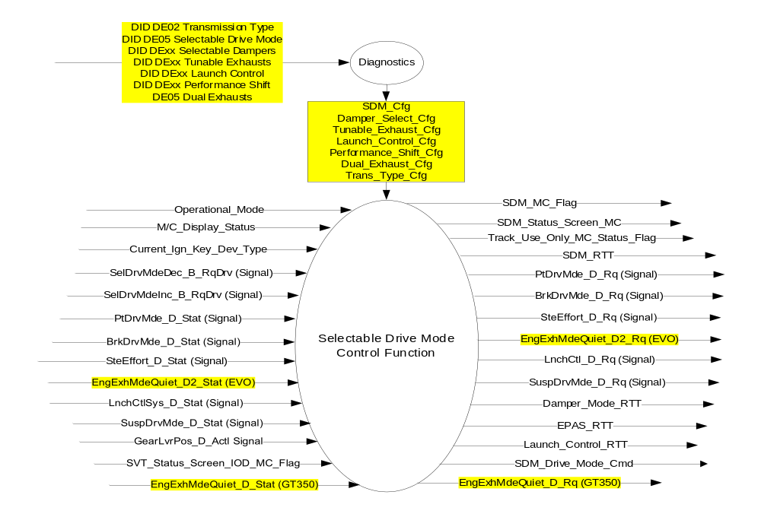

Inputs

- INTERNAL:
- Operational_Mode
- M/C_Display_Status
- Current_Ign_Key_Dev_Type (from MyKey Control Function STSS)
- SDM_Cfg - Internally stored bit based on SDM parameter of DID DE05 indicating if the SDM feature is Enabled (0x1) or Disabled (0x0)
- SVT_Status_Screen_IOD_MC_Flag (from Status Screen Information – S550 SVT Only - CGEA1.3 STSS)

- MUX messages on the CAN bus:

- GearLvrPos_D_Actl Signal
Signal Name | Size  (bits) | Detail | Units | Res. | Offset | State  Encoded | Min | Max
GearLvrPos_D_Actl | 4 |  | SED | 1 | 0 |  | 0 (0x0) | 15 (0xF)
 |  | Park |  |  |  | 0x0
 |  | Reverse |  |  |  | 0x1
 |  | Neutral |  |  |  | 0x2
 |  | Drive |  |  |  | 0x3
 |  | Sport/Drive Sport |  |  |  | 0x4
 |  | Low |  |  |  | 0x5
 |  | 1 |  |  |  | 0x6
 |  | 2 |  |  |  | 0x7
 |  | 3 |  |  |  | 0x8
 |  | 4 |  |  |  | 0x9
 |  | 5 |  |  |  | 0xA
 |  | 6 |  |  |  | 0xB
 |  | Undefined |  |  |  | 0xC
 |  | Undefined |  |  |  | 0xD
 |  | Unknown Position |  |  |  | 0xE
 |  | Fault |  |  |  | 0xF

- SelDrvMdeInc_B_RqDrv Signal
Signal Name | Size  (bits) | Detail | Units | Res. | Offset | State  Encoded | Min | Max
SelDrvMdeInc_B_RqDrv | 1 |  | SED | 1 | 0 |  | 0 (0x0) | 1 (0x1)
 |  | Not pressed |  |  |  | 0x0
 |  | Pressed |  |  |  | 0x1

- SelDrvMdeDec_B_RqDrv Signal
Signal Name | Size  (bits) | Detail | Units | Res. | Offset | State  Encoded | Min | Max
SelDrvMdeDec_B_RqDrv | 1 |  | SED | 1 | 0 |  | 0 (0x0) | 1 (0x1)
 |  | Not pressed |  |  |  | 0x0
 |  | Pressed |  |  |  | 0x1

- SteEffort_D_Stat Signal
Signal Name | Size  (bits) | Detail | Units | Res. | Offset | State  Encoded | Min | Max
SteEffort_D_Stat | 3 |  | SED | 1 | 0 |  | 0 (0x0) | 7 (0x7)
 |  | Normal |  |  |  | 0x0
 |  | Sport |  |  |  | 0x1
 |  | Comfort |  |  |  | 0x2
 |  | SpecialMode_1 |  |  |  | 0x3
 |  | SpecialMode_2 |  |  |  | 0x4
 |  | Not Used |  |  |  | 0x5
 |  | Not Used |  |  |  | 0x6
 |  | Not Used |  |  |  | 0x7

- PtDrvMde_D_Stat Signal
Signal Name | Size  (bits) | Detail | Units | Res. | Offset | State  Encoded | Min | Max
PtDrvMde_D_Stat | 4 |  | SED | 1 | 0 |  | 0 (0x0) | 15 (0xF)
 |  | Normal |  |  |  | 0x0
 |  | Sport |  |  |  | 0x1
 |  | SnowWet |  |  |  | 0x2
 |  | TowHaulGradeAssist |  |  |  | 0x3
 |  | Sand |  |  |  | 0x4
 |  | Baja |  |  |  | 0x5
 |  | RockCrawl |  |  |  | 0x6
 |  | Drag |  |  |  | 0x7
 |  | Not Used |  |  |  | 0x8
 |  | Not Used |  |  |  | 0x9
 |  | Not Used |  |  |  | 0xA
 |  | Not Used |  |  |  | 0xB
 |  | Not Used |  |  |  | 0xC
 |  | Not Used |  |  |  | 0xD
 |  | Not Used |  |  |  | 0xE
 |  | Faulty |  |  |  | 0xF

- BrkDrvMde_D_Stat Signal
Signal Name | Size  (bits) | Detail | Units | Res. | Offset | State  Encoded | Min | Max
BrkDrvMde_D_Stat | 3 |  | SED | 1 | 0 |  | 0 (0x0) | 7 (0x7)
 |  | Normal |  |  |  | 0x0
 |  | Sport |  |  |  | 0x1
 |  | Snow_Wet |  |  |  | 0x2
 |  | Track |  |  |  | 0x3
 |  | Drag |  |  |  | 0x4
 |  | Not Used |  |  |  | 0x5
 |  | Not Used |  |  |  | 0x6
 |  | Faulty |  |  |  | 0x7

- SuspDrvMde_D_Stat Signal
Signal Name | Size  (bits) | Detail | Units | Res. | Offset | State  Encoded | Min | Max
SuspDrvMde_D_Stat | 3 |  | SED | 1 | 0 |  | 0 (0x0) | 7 (0x7)
 |  | Normal |  |  |  | 0x0
 |  | Sport |  |  |  | 0x1
 |  | Snow_Wet |  |  |  | 0x2
 |  | Track |  |  |  | 0x3
 |  | Drag |  |  |  | 0x4
 |  | NotUsed1 |  |  |  | 0x5
 |  | NotUsed2 |  |  |  | 0x6
 |  | Faulty |  |  |  | 0x7

- EngExhMdeQuiet_D2_Stat Signal (For EVO)
Signal Name | Size (bits) | Detail | Units | Res. | Offset | State Encoded | Min | Max
EngExhMdeQuiet_D2_Stat | 3 |  | SED | 1 | 0 |  | 0 (0x0) | 7 (0x7)
 |  | Null |  |  |  | 0x0
 |  | Stealth |  |  |  | 0x1
 |  | Normal |  |  |  | 0x2
 |  | Sport |  |  |  | 0x3
 |  | Track |  |  |  | 0x4
 |  | NotUsed |  |  |  | 0x5
 |  | NotUsed |  |  |  | 0x6
 |  | Faulty |  |  |  | 0x7

- LaunchCtlSys_D_Stat Signal
Signal Name | Size (bits) | Detail | Units | Res. | Offset | State Encoded | Min | Max
LnchCtlSys_D_Stat | 3 |  | SED | 1 | 0 |  | 0 (0x0) | 7 (0x7)
 |  | LC_OFF |  |  |  | 0x0
 |  | On_LC_Active |  |  |  | 0x1
 |  | On_LC_Available |  |  |  | 0x2
 |  | On_LC_Unavailable |  |  |  | 0x3
 |  | On_LC_Unavailable_TC_On |  |  |  | 0x4
 |  | NotUsed1 |  |  |  | 0x5
 |  | NotUsed2 |  |  |  | 0x6
 |  | NotUsed3 |  |  |  | 0x7

- EngExhMdeQuiet_D_Stat Signal (For GT350)
Signal Name | Size (bits) | Detail | Units | Res. | Offset | State Encoded | Min | Max
EngExhMdeQuiet_D_Stat | 3 |  | SED | 1 | 0 |  | 0 (0x0) | 3 (0x3)
 |  | Null |  |  |  | 0x0
 |  | LoudExhaust |  |  |  | 0x1
 |  | QuietExhaust |  |  |  | 0x2
 |  | NotUsed |  |  |  | 0x3

Outputs
- SDM_RTT
- SDM_Drive_Mode_Cmd
- SDM_Status_Screen_MC – SDM State displayed under the SVT Status Screen
- Damper_RTT – Please refer to the “Selectable Damper Control Function – CGEA1.3” STSS for more information.
- EPAS_RTT – Please refer to the “EPAS Selectable Steering Effort Control Function – S550 Specific – CGEA1.3 v3.0” or newer version of STSS for more information.
- Launch_Control_RTT – Please refer to the “Launch Control Performance Function – S550 Specific CGEA1.3” STSS for more information.
- SDM_MC_Flag
- Track_Use_Only_MC_Status_Flag
- MUX messages on the CAN bus:

- SteEffort_D_Rq Signal
Signal Name | Size  (bits) | Detail | Units | Res. | Offset | State  Encoded | Min | Max
SteEffort_D_Rq | 3 |  | SED | 1 | 0 |  | 0 (0x0) | 7 (0x7)
 |  | Normal |  |  |  | 0x0
 |  | Sport |  |  |  | 0x1
 |  | Comfort |  |  |  | 0x2
 |  | SpecialMode_1 |  |  |  | 0x3
 |  | SpecialMode_2 |  |  |  | 0x4
 |  | Not Used |  |  |  | 0x5
 |  | Not Used |  |  |  | 0x6
 |  | Not Used |  |  |  | 0x7

- PtDrvMde_D_Rq Signal
Signal Name | Size  (bits) | Detail | Units | Res. | Offset | State  Encoded | Min | Max
PtDrvMde_D_Rq | 4 |  | SED | 1 | 0 |  | 0 (0x0) | 15 (0xF)
 |  | Normal |  |  |  | 0x0
 |  | Sport |  |  |  | 0x1
 |  | SnowWet |  |  |  | 0x2
 |  | TowHaulGradeAssist |  |  |  | 0x3
 |  | Sand |  |  |  | 0x4
 |  | Baja |  |  |  | 0x5
 |  | RockCrawl |  |  |  | 0x6
 |  | Drag |  |  |  | 0x7
 |  | Not Used |  |  |  | 0x8
 |  | Not Used |  |  |  | 0x9
 |  | Not Used |  |  |  | 0xA
 |  | Not Used |  |  |  | 0xB
 |  | Not Used |  |  |  | 0xC
 |  | Not Used |  |  |  | 0xD
 |  | Not Used |  |  |  | 0xE
 |  | Faulty |  |  |  | 0xF

- BrkDrvMde_D_Rq Signal
Signal Name | Size  (bits) | Detail | Units | Res. | Offset | State  Encoded | Min | Max
BrkDrvMde_D_Rq | 3 |  | SED | 1 | 0 |  | 0 (0x0) | 7 (0x7)
 |  | Normal |  |  |  | 0x0
 |  | Sport |  |  |  | 0x1
 |  | Snow_Wet |  |  |  | 0x2
 |  | Track |  |  |  | 0x3
 |  | Drag |  |  |  | 0x4
 |  | Not Used |  |  |  | 0x5
 |  | Not Used |  |  |  | 0x6
 |  | Faulty |  |  |  | 0x7

- SuspDrvMde_D_Rq Signal
Signal Name | Size  (bits) | Detail | Units | Res. | Offset | State  Encoded | Min | Max
SuspDrvMde_D_Rq | 3 |  | SED | 1 | 0 |  | 0 (0x0) | 7 (0x7)
 |  | Normal |  |  |  | 0x0
 |  | Sport |  |  |  | 0x1
 |  | Snow_Wet |  |  |  | 0x2
 |  | Track |  |  |  | 0x3
 |  | Drag |  |  |  | 0x4
 |  | NotUsed1 |  |  |  | 0x5
 |  | NotUsed2 |  |  |  | 0x6
 |  | Faulty |  |  |  | 0x7

- EngExhMdeQuiet_D2_Rq Signal (for EVO)
Signal Name | Size  (bits) | Detail | Units | Res. | Offset | State Encoded | Min | Max
EngExhMdeQuiet_D2_Rq | 3 |  | SED | 1 | 0 |  | 0(0x0) | 7(0x7)
 |  | Null |  |  |  | 0x0
 |  | Stealth |  |  |  | 0x1
 |  | Normal |  |  |  | 0x2
 |  | Sport |  |  |  | 0x3
 |  | Track |  |  |  | 0x4
 |  | NotUsed |  |  |  | 0x5
 |  | NotUsed |  |  |  | 0x6
 |  | NotUsed |  |  |  | 0x7

- LnchCtlSys_D_Rq Signal
Signal Name | Size  (bits) | Detail | Units | Res. | Offset | State Encoded | Min | Max
LnchCtl_D_Rq | 2 |  | SED | 1 | 0 |  | 0(0x0) | 3(0x3)
 |  | LC_OFF |  |  |  | 0x0
 |  | LC_ON |  |  |  | 0x1
 |  | Reserved |  |  |  | 0x2
 |  | Reserved |  |  |  | 0x3

- EngExhMdeQuiet_D_Rq Signal (For GT350)
Signal Name | Size (bits) | Detail | Units | Res. | Offset | State Encoded | Min | Max
EngExhMdeQuiet_D_Rq | 3 |  | SED | 1 | 0 |  | 0 (0x0) | 3 (0x3)
 |  | Null |  |  |  | 0x0
 |  | LoudExhaust |  |  |  | 0x1
 |  | QuietExhaust |  |  |  | 0x2
 |  | NotUsed |  |  |  | 0x3

Function/Performance

Operational Modes

Mode | Differentiating Vehicle Conditions
Sleep Mode | Selectable Drive Mode Control Function Disabled
Limited Mode | Selectable Drive Mode Control Function Disabled
Normal Mode | Selectable Drive Mode Control Function Enabled / Disabled
Crank Mode | Selectable Drive Mode Control Function Enabled / Disabled

Voltage Levels

Refer to the Cluster Features table located in the Operational Modes and Voltage Range Strategies Section in this SPSS.

Human-Machine Interface

Visual

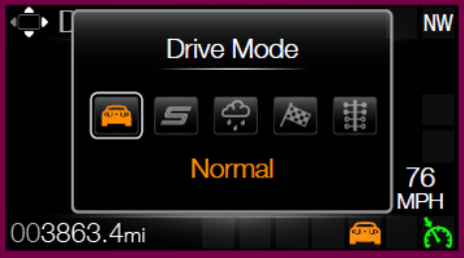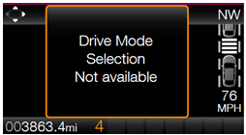

Graphics are for illustrative purposes only; refer to program specific graphics library.
.

Indicator Graphics / Display Format


For actual symbol pixel definition, see program specific HMI requirements.
Refer to symbols tbd.26, tbd.27, tbd.28, tbd.33, and tbd.34.

Indicator Color Coordinates

Refer to program specific HMI requirements for styling direction.

Indicator Characteristics

Pixel display in Message Center Display – SDM_RTT.

Audio

None

Switch Control Logic

The SCCM module transmits an event periodic CAN signal to inform the IPC if either of the buttons (Mode+ or Mode-) is pressed or not pressed. The SCCM handles all switch debouncing and fault conditions related to the momentary toggle switches without relaying this information to the cluster. A button press is defined as a transition from Not Pressed to Pressed. There is no press and hold for the buttons – a press and hold shall constitute a single button press.

System Accuracy

Within a 100msec of receiving a message that results in a change of state the cluster will update the display to the proper status.

Operation: Performance and Functional

Subsystem Algorithm Flowcharts / State Diagrams

Figure 2: Selectable Drive Mode Control Feature Diagnostic Flowchart

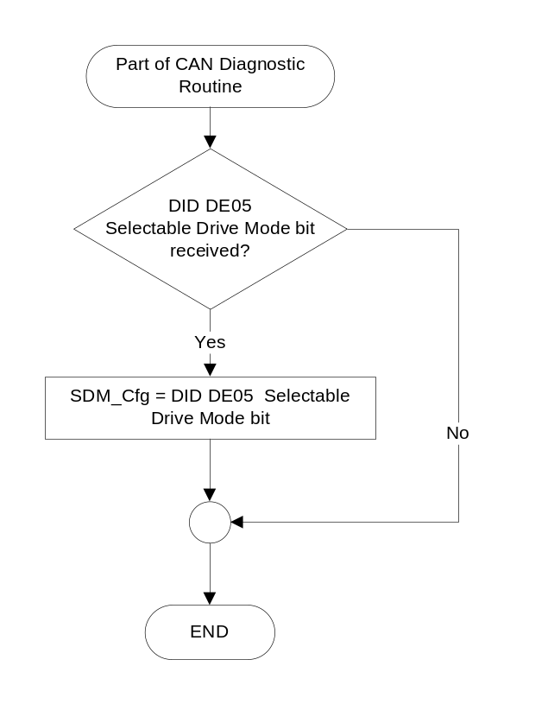

EPAS_Btn_Cfg: Please refer to the “EPAS Selectable Steering Effort Control Function – S550 Specific – CGEA1.3” STSS for information on the definition of this configuration bit.

Launch_Control_Cfg: Please refer to the “Launch Control Performance Function – S550 Specific CGEA1.3” STSS for more information on the definition of this configuration bit.

Damper_Select_Cfg: Please refer to the “Damper Settings Function – CGEA1.3” STSS for more information on the definition of this configuration bit.

Tunable_Exhausts_Cfg: Please refer to the “Tunable Exhaust Mode Control Function – CGEA1.3” STSS for more information on the definition of this configuration bit.

Performance_Shift_Cfg: Please refer to the “Performance Shift Indicator Control Function – S%00 Specific CGEA1.3” STSS for more information on this configuration bit.

Dual_Exhaust_Cfg: Please refer to the “Dual Mode Exhaust Control Function – CGEA1.3” for more information on this configuration bit.
Figure 3: Selectable Drive Mode Control Function Flowchart
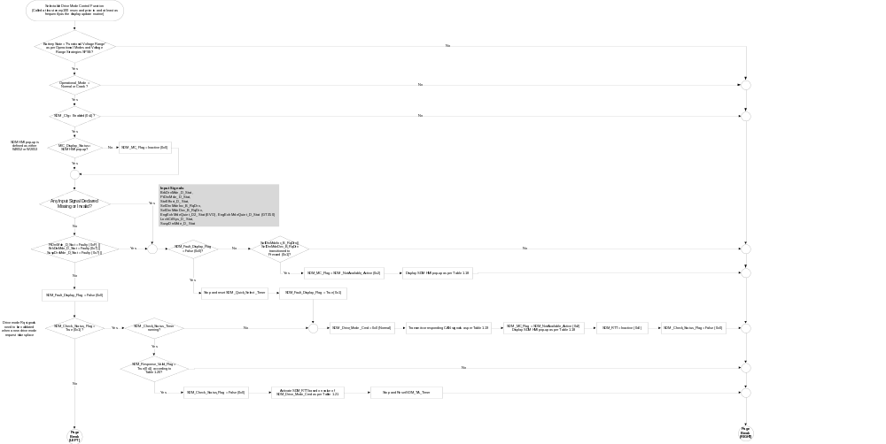

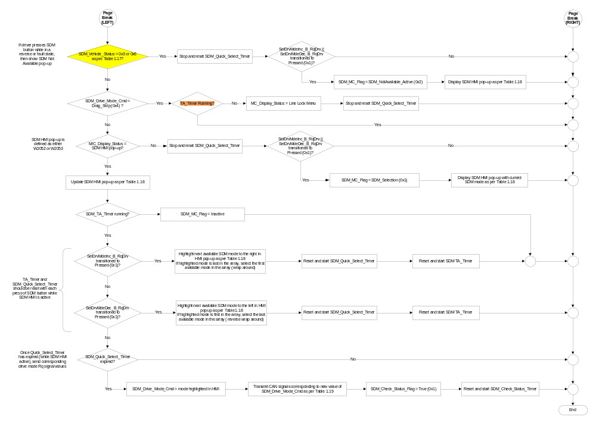
- SDM Mode Availability Based SDM_Cfg, Selected Gear, and MyKey Settings
SDM_Cfg | Trans_Type_Cfg | Selected Gear Position | Current_Ign_Key_Dev_Type | SDM_Vehicle_Status |  | Valid States for SDM_Drive_Mode_Cmd
Enabled (0x1) | Auto (0x0) | Gear Display = P, N, D or M | <> Key_In_Ign_My_Key (0x2) | 0x1 |  | Normal (0x0)  Sport (0x1)  Track (0x2)  Drag Strip (0x3)  Slippery (0x4)
Enabled (0x1) | Auto (0x0) | Gear Display = P, N, D or M | Key_In_Ign_My_Key (0x2) | 0x2 |  | Normal (0x0)  Slippery (0x4)
Enabled (0x1) | Auto (0x0) | Gear Display  <> [0x0, 0x2, 0x3, 0x4]  (Reverse, Fault, Unused state) | X | 0x3 |  | SDM Not Available
Enabled (0x1) | Manual (0x1) | GearRvrse_D_Actl  Inactive_not_confirmed (0x0)  Inactive_ confirmed (0x1)  (Forward or neutral gear) | <> Key_In_Ign_My_Key (0x2) | 0x4 |  | Normal (0x0)  Sport (0x1)  Track (0x2)  Drag Strip (0x3)  Slippery (0x4)
Enabled (0x1) | Manual (0x1) |  | Key_In_Ign_My_Key (0x2) | 0x5 |  | Normal (0x0)  Slippery (0x4)
Enabled (0x1) | Manual (0x1) | GearRvrse_D_Actl  <> [0x0, 0x1]  (Reverse, Fault, Unused state) | X | 0x6 |  | SDM Not Available
All other cases |  |  |  |  | X |  | SDM Not Available

- Sample Graphics and MC WARNING MESSAGE ID # Based on SDM_MC_Flag
SDM_Cfg | SDM_MC_Flag |  | MC WARNING  MESSAGE ID # |  | SDM Pop-up Sample Graphics  *See Note Below
Enabled (0x1) | SDM_Selection  _Active (0x1) |  | W2053 |  | 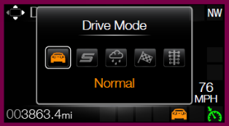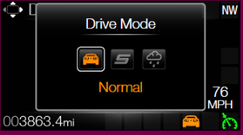  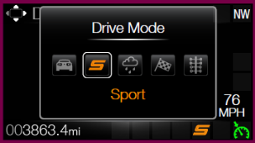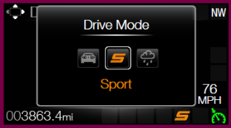  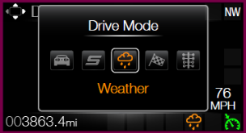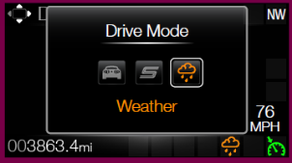  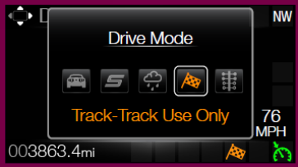  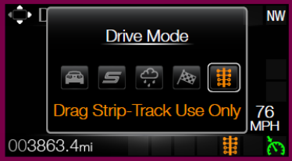
 |  | SDM_  NotAvailable_  Active (0x2) |  | W2052 |  | 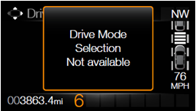
All other cases |  |  | X |  | No graphic shown

Note: W2053 should illustrate the available drives modes based on Table 1.15, where the highlighted

mode is the current value of SDM_Drive_Mode_Cmd.

- SDM_Drive_Mode_Cmd to Drive Mode Request Signals Mapping (for EVO)
SDM_Drive_Mode_Cmd | PtDrvMde_D_Rq Signal | BrkDrvMde_D_Rq Signal | SteEffort_D_Rq Signal | EngExhMdeQuiet_D2_Rq Signal  (if Tunable_Exhaust_Cfg = Enabled (0x1)) | LnchCtlSys_B_RqDrv Signal  (if Launch_Control_Cfg = Enabled (0x1) | SuspDrvMde_D_Rq Signal  (If Damper_Select_Cfg = Enabled (0x1))
Normal (0x0) | Normal (0x0) | Normal (0x0) | Normal (0x0) | Normal (0x2) | Launch_Control_MC | Normal (0x0)
Sport (0x1) | Sport (0x1) | Sport (0x1) | Sport (0x1) | Sport (0x1) | Launch_Control_MC | Sport (0x1)
Track (0x2)* | Baja (0x5) | Track (0x3) | Sport (0x1) | Track (0x4) | Launch_Control_MC | Track (0x3)
Drag Strip (0x3)* | Drag (0x7) | Drag (0x4) | Normal (0x0) | Track (0x4) | LC_ON (0x1) | Drag (0x4)
Slippery (0x4) | SnowWet (0x2) | Snow_Wet (0x2) | Normal (0x0) | Normal (0x2) | LC_OFF | Normal (0x1)

- SDM_Response_Valid_Flag State Matrix (for EVO)
SDM_Drive_  Mode_Cmd | PtDrvMde_D_Stat Signal | BrkDrvMde_D_Stat Signal | SteEffort_D_Stat Signal | EngExhMdeQuiet_D2_Stat Signal  (if Tunable_Exhaust_Cfg = Enabled (0x1)) | LnchCtlSys_D_Stat Signal  if Launch_Control_  Cfg = Enabled (0x1) | SuspDrvMde_D_Stat Signal  (If Damper_Select_Cfg = Enabled (0x1)) | SDM_Response_Valid_Flag
Normal (0x0) | Normal (0x0) | Normal (0x0) | Normal (0x0) | Normal (0x2)  ||  Faulty (0x7) | X | Normal (0x0) | True (0x1)
Sport (0x1) | Sport (0x1) | Sport (0x1) | Sport (0x1) | Sport (0x3)  ||  Faulty (0x7) | X | Sport (0x1) | True (0x1)
Track (0x2)* | Baja (0x5) | Track (0x3) | Sport (0x1) | Track (0x4)  ||  Faulty (0x7) | X | Track (0x3) | True (0x1)
Drag Strip (0x3)* | Drag (0x7) | Normal (0x0)  or  Drag (0x4) | Normal (0x0) | Normal (0x4)  ||  Faulty (0x7) | X | Drag (0x4) | True (0x1)
Slippery (0x4) | SnowWet (0x2) | Snow_Wet (0x2) | Normal (0x0) | Normal (0x2)  ||  Faulty (0x7) | X | Normal (0x0) | True (0x1)
All other cases |  |  |  |  |  |  |  | False (0x0)
* If cluster end item part number is for an EVO variant, “Baja (0x5)” PCM state shall be requested for Track Mode, and “Drag (0x7)” state shall be requested for Drag Mode.

- SDM_Drive_Mode_Cmd to Drive Mode Request Signals Mapping (for GT350)
SDM_Drive_Mode_Cmd | PtDrvMde_D_Rq Signal | BrkDrvMde_D_Rq Signal | SteEffort_D_Rq Signal | EngExhMdeQuiet_  D_Rq Signal  (if Dual_Exhaust_Cfg = Enabled (0x1)) | LnchCtlSys_B_RqDrv Signal  (if Launch_Control_Cfg = Enabled (0x1) | SuspDrvMde_D_Rq Signal  (If Damper_Select_Cfg = Enabled (0x1))
Normal (0x0) | Normal (0x0) | Normal (0x0) | Normal (0x0) | QuietExhaust (0x2) | Launch_Control_MC | Normal (0x0)
Sport (0x1) | Sport (0x1) | Sport (0x1) | Sport (0x1) | LoudExhaust (0x1) | Launch_Control_MC | Sport (0x1)
Track (0x2)* | Normal (0x0) | Track (0x3) | Sport (0x1) | LoudExhaust (0x1) | Launch_Control_MC | Track (0x3)
Drag Strip (0x3)* | Sport (0x1) | Drag (0x4) | Normal (0x0) | LoudExhaust (0x1) | LC_ON (0x1) | Drag (0x4)
Slippery (0x4) | SnowWet (0x2) | Snow_Wet (0x2) | Normal (0x0) | QuietExhaust (0x2) | Launch_Control_MC | Normal (0x1)

- SDM_Response_Valid_Flag State Matrix (for GT350)
SDM_Drive_  Mode_Cmd | PtDrvMde_D_Stat Signal | BrkDrvMde_D_Stat Signal | SteEffort_D_Stat Signal | EngExhMdeQuiet_D_Stat Signal  (if Dual_Exhaust_Cfg = Enabled (0x1)) | LnchCtlSys_D_Stat Signal  if Launch_Control_  Cfg = Enabled (0x1) | SuspDrvMde_D_Stat Signal  (If Damper_Select_Cfg = Enabled (0x1)) | SDM_Response_Valid_Flag
Normal (0x0) | Normal (0x0) | Normal (0x0) | Normal (0x0) | QuietExhaust (0x2)  ||  Null (0x0) | X | Normal (0x0) | True (0x1)
Sport (0x1) | Sport (0x1) | Sport (0x1) | Sport (0x1) | LoudExhaust (0x1)  ||  Null (0x0) | X | Sport (0x1) | True (0x1)
Track (0x2)* | Normal (0x0) | Track (0x3) | Sport (0x1) | LoudExhaust (0x1)  ||  Null (0x0) | X | Track (0x3) | True (0x1)
Drag Strip (0x3)* | Sport (0x1) | Normal (0x0)  or  Drag (0x4) | Normal (0x0) | LoudExhaust (0x1)  ||  Null (0x0) | X | Drag (0x4) | True (0x1)
Slippery (0x4) | SnowWet (0x2) | Snow_Wet (0x2) | Normal (0x0) | QuietExhaust (0x2)  ||  Null (0x0) | X | Normal (0x0) | True (0x1)
All other cases |  |  |  |  |  |  |  | False (0x0)
* If cluster end item part number is for a GT 350 variant, “Normal (0x0)” PCM state shall be requested for Track Mode, and “Sport (0x1)” state shall be requested for Drag Mode.

Figure 4: Selectable Drive Mode RTT Activation Process Flowchart
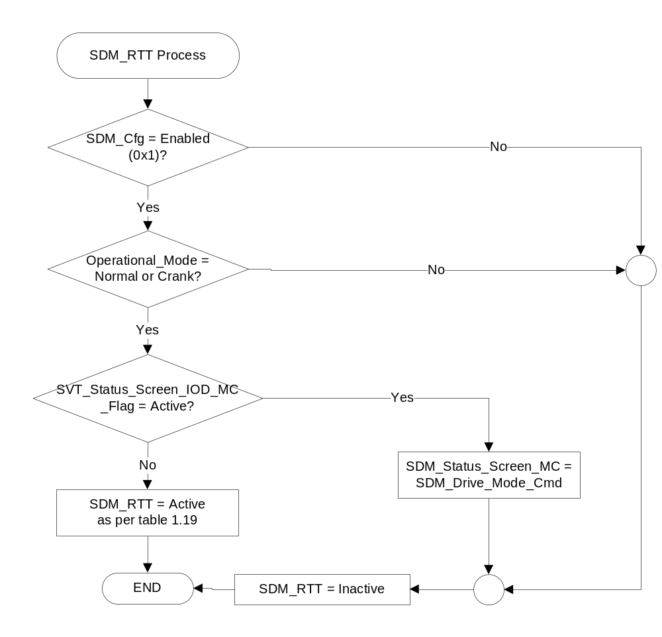

- SDM_RTT, EPAS_RTT, Damper_Mode_RTT, Launch_Control_RTT and Sample RTT Graphics Based on SDM_Drive_Mode_Cmd
SDM_Drive_Mode_Cmd | SDM_RTT | EPAS_RTT | Damper_Mode  _RTT | Launch_Control  _RTT
Normal (0x0) | Normal (0x0) |   Normal |   Normal | Inactive
Sport (0x1) | Sport (0x1) |   Sport |   Sport | Inactive
Weather (0x2) | Weather (0x2) | Normal | Normal | Inactive
Track (0x3) | Track (0x3) | Sport |   Road Course | Inactive
Drag Strip (0x4) | Drag Strip (0x4) | Normal | 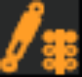  Drag | 
All other cases | Inactive (0x0) | Inactive | Inactive | Inactive
Note: Graphics shown above are for example purposes only. Please refer to the program specific wallpaper for accurate graphics.

- State matrix for Track Use Only warning (non-EVO variants)
Operational_  Mode | SDM_Cfg | Dual_Exhaust_  Cfg | SDM_Drive_Mode_  Cmd | SDM_Response_  Valid_Flag | EngExhMdeQuiet_  D_Stat Signal | Track_Use_Only_  MC_Status_Flag  (Msg ID: W3575)
Normal or Crank | Enabled (0x1) | Enabled (0x1) | Track (0x3)  Or  Drag Strip (0x4) | True (0x1) | LoudExhaust (0x1) | Active
All Other Cases |  |  |  |  |  | Inactive

- State matrix for Track Use Only warning (EVO variants)
Operational_  Mode | SDM_Cfg | Tunable_Exhaust_Cfg | SDM_Drive_Mode_  Cmd | SDM_Response_  Valid_Flag | EngExhMdeQuiet_  D2_Stat Signal | Track_Use_Only_  MC_Status_Flag  (Msg ID: W3575)
Normal or Crank | Enabled (0x1) | Enabled (0x1) | Track (0x3)  Or  Drag Strip (0x4) | True (0x1) | Track (0x4) | Active
All Other Cases |  |  |  |  |  | Inactive

W3575 is triggered as per the SDM logic in this STSS, and is independent of the exhaust mode set via the message center switches in the Settings item of the cluster menu.

Operation Description (supports algorithm flowcharts / state diagrams)

- There is no interaction between the 5-way steering wheel switches and the SDM feature. SDM is controlled directly via an external, two-way momentary toggle switch (Mode+ and Mode-), which is located in the SCCM. The SCCM is responsible for sending debounced pressed/not pressed information to the cluster via the SDMIncButtnPress or the SDMDecButtnPress signals.

- The first press of either the Mode+ or the Mode- buttons shall bring up the SDM HMI pop-up. Subsequent presses of either of these two buttons shall advance the HMI to the next state/mode if the SDM HMI pop-up is active. SDM_Drive_Mode_Cmd and the corresponding CAN Rq signals shall not change until after the Quick_Select_Timer has elapsed according to the logic in Figure 3.

- The Mode+ button shall advance the HMI to the next mode to the right (move forward) of the array. If the highlighted mode happens to be the last one in the array, the button shall advance the HMI to the first available mode in the array (wrap around).
- The Mode- button shall advance the HMI to the next mode to the left (move backward) of the array. If the highlighted mode happens to be the first one in the array, the button shall advance the HMI to the last available mode in the array (reverse wrap around).

- Each press of the Mode (+ or -) button shall reset and restart the TA_timer for the SDM HMI pop-up if the SDM HMI is already active.

- If the selected SDM mode is “Drag Strip”, the cluster shall jump to the Line Lock Menu once the mode has been confirmed (all status signals received as per table 1.18) and the temporary alert timer has expired.

- If the SDM HMI is interrupted by any other pop-up or warning before the Quick_Select_Timer has elapsed, the SDM mode selection process should be aborted.

- Once the Quick_Select_Timer has elapsed, if another pop-up or warning gets activated, the SDM pop-up shall be deactivated as soon as the SDM mode display has been updated. (The SDM mode update can be concluded as complete once the “SDM_Check_Status_Flag” has a value of “False” (0x0) and corresponding RTT (if applicable) has been activated.).The SDM pop-up shall not wait for the minimum display timer to expire.

- W2053 (SDM selection screen) is a TA* warning as per the global warning message list. However, based on the cluster specific HMI theme, the screen may or may not share the same area as other warnings on the cluster display. W2053 shall behave as a TA* warning when it is displayed for the first time. (as per figure 3) Also, if SDM_MC_Flag <> SDM_Selection_Active (0x1), then W2053 should be dismissed.

- W2052 is a TA warning as per the global warning message list. Therefore, the value of SDM_MC_Flag does not have a direct impact on the dismissal of W2052.

- “Track” and “Drag Strip” modes shall not be available for selection when a vehicle is driven using a MyKey. The cluster shall either gray out or not display the unavailable modes. (Product specific HMI strategy).

- Upon key-on, SDM_Drive_Mode_Cmd shall default to Normal (0x0), PtDrvMde_D_Rq shall default to Normal (0x0), BrkDrvMde_D_Rq shall default to Normal (0x0), SuspDrvMde_D_Rq shall default to Normal (0x0), EngExhMdeQuiet_D2_Rq (EVO) shall default to Normal (0x2) or EngExhMdeQuiet_D_Rq (GT350) shall default to QuietExhaust (0x2), and SteEffort_D_Rq shall default to EPAS_Keyon_Effort as per “EPAS Selectable Steering Effort Function - S550 Specific - CGEA 1.3_v2.0+”.

- SDM is not related to, nor does it have any defined interactions with, the “Track Apps” or “TracKey” features.

- The IPC is responsible for requesting SDM modes, but it is the acting modules’ responsibility to make the appropriate decisions to determine if the request can be fulfilled and respond positively or negatively via its status signal.

- The request and status for the Damper modes, Dual Exhaust mode and Launch Control should only be monitored if the individual feature configurations have been Enabled. Else, the cluster should only monitor for the standard features. (as per table 1.17 and 1.18).

- The SDM_RTT shall only be displayed when the SVT Status Screen is not actively displayed.

- Based on change in the Drive mode, the EPAS_RTT, DAMPER_RTT and Launch_Control_RTT shall only be updated if each of the individual features is configured as Enabled (0x1).

- The individual RTTs (Damper_Mode_RTT, EPAS_RTT, Launch_Control_RTT) shall be controlled through the individual functional STSS requirements if changed via the individual button presses.

Function Safety Classification (EMC)

Class B

Memory Storage
Parameter Name | Description | Value at  Battery Connect | Value at  Module Wake-up
Operational_Mode | 4 state indicator for cluster operational mode. | Limited | Limited, Normal or Crank
Current_Ign_Key_Dev_Type | Used to indicate the type of key currently in use in the vehicle. This parameter is identical in encoding to the IgnKeyType_D_Actl signal. | See STSS: “MyKey Control Function” | See STSS: “MyKey Control Function”
SVT_Status_Screen_IOD_MC_Flag | Internal input from “Status Screen Information Display – CGEA1.3” STSS
M/C_Display_Status | State indicator to identify which text is currently being displayed on Message Center display. See * | See * below | See * below
SelDrvMdeInc_B_RqDrv | Input CAN signal that provides the debounced state of the SDM Mode + button (Pressed / Not pressed). | Not pressed (0x0) | Not pressed (0x0)
SelDrvMdeDec_B_RqDrv | Input CAN signal that provides the debounced state of the SDM Mode - button (Pressed / Not pressed). | Not pressed (0x0) | Not pressed (0x0)
GearRvrse_D_Actl | Input CAN signal for manual transmission vehicles that indicates whether the vehicle is in reverse or not. | Fault (0x7) | Fault (0x7)
PtDrvMde_D_Stat | Input CAN signal that provides the current powertrain mode status. | Normal (0x0) | Normal (0x0)
BrkDrvMde_D_Stat | Input CAN signal that provides the current ABS mode status. | Normal (0x0) | Normal (0x0)
SteEffort_D_Stat | Input CAN signal that provides the current EPAS steering feel status. | Normal (0x0) | Normal (0x0)
EngExhMdeQuiet_D_Stat | Input CAN signal that provides the current dual mode exhaust status. | QuietExhaust (0x2) | QuietExhaust (0x2)
EngExhMdeQuiet_D2_Stat | Input CAN signal that provides the current dual mode exhaust status. | Normal (0x2) | Normal (0x2)
PtDrvMde_D_Rq | Output CAN signal to request a certain powertrain drive mode. | Normal (0x0) | Normal (0x0)
BrkDrvMde_D_Rq | Output CAN signal to request a certain ABS-ESC mode. | Normal (0x0) | Normal (0x0)
SteEffort_D_Rq | Output CAN signal to request a certain EPAS steering feel. | Normal (0x0) | See STSS: “EPAS Selectable Steering  Effort Function -  S550 Specific - CGEA 1.3 _v2.0+”
EngExhMdeQuiet_D2_Rq | Output CAN signal to request a certain dual mode exhaust setting | Normal (0x2) | Normal (0x2)
EngExhMdeQuiet_D_Rq | Output CAN signal to request a certain dual mode exhaust setting | QuietExhaust (0x2) | QuietExhaust (0x2)
SDM_Check_Status_Flag | Internal parameter used to flag if the SDM handshaking (status checking) logic should take place. | False (0x0) | False (0x0)
SDM_Cfg | Internal flag used to indicate if SDM feature is present in the vehicle. | Use Stored Value | Use Stored Value
SDM_Drive_Mode_Cmd | Output parameter that represents the current requested SDM mode. This parameter is identical in encoding to the Selectable_Drive_Mode_Stat DID. | Normal (0x0) | Normal (0x0)
SDM_Fault_Display_Flag | Internal parameter used to flag if SDM fault has occurred and has already been displayed. | False (0x0) | False (0x0)
SDM_MC_Flag | Internal flag used to control the state of the SDM selection pop-up. This variable can dismiss the SDM selection pop-up prior to the expiration of the TA_Timer. Encoding is as follows: Inactive (0x0), SDM_Selection_Active (0x1), and SDM_NotAvailable_Active (0x2). | Inactive (0x0) | Inactive (0x0)
SDM_RTT | SDM output displayed as an RTT. Encoding includes: Inactive (0x0), Snow/Wet (0x1), Sport+ (0x1), and Track (0x2). | Inactive (0x0) | Inactive (0x0)
SDM_Response_Valid_Flag | Internal parameter used to check if drive mode status signals (from PCM, ABS, and PSCM) are valid after a new drive mode request. | False (0x0) | False (0x0)
Track_Use_Only_MC_Status_  Flag | Confirmation status flag passed on to the warning arbitrator | Inactive | Inactive
SDM_Vehicle_Status | Internal parameter that indicates the vehicle status based on Table 1.11. | 0x0 | 0x0
SDM_Status_Screen_MC | Varaiable that holds the SDM status to be displayed on the SVT Status screen. | SDM_MC_Flag | SDM_MC_Flag
Trans_Type_Cfg | Internal flag used to indicate if transmission is automatic or manual. | Use Stored Value | Use Stored Value
* Refer to Message Center X Display_Y Button Interface Section, where X and Y are appropriate values in this document.

Timer Name | Duration | Description | Min | Max | Resolution
SDM_Check_Status_Timer | 300ms | Used to limit the amount of time that EPAS, VDM, PCM, and ABS modules have to respond positively to a change in SDM mode. | 0ms | 2000ms | 50ms
SDM_Quick_Select_Timer | 700ms | Used to suppress the transmission of new SDM mode requests in between SDM button presses. | 0ms | 3000ms | 50ms
Note: Timers shall be programmable within the shown range, to at least the max value listed. Higher max values and finer resolutions are acceptable.

Reconfigurable Telltale

Yes. See Section 1.3.3.2 Indicator Graphics / Display Format, and Table 1.13.

Prove Out

Not applicable.

Message Center Msg

Yes. See Section 1.3.3.1 Visual, and Table 1.10.

Error Handling

Missing Message Strategy

The signals will be declared missing as per the Diagnostics section of this STSS.
DTCs states and history will be determined as per the Diagnostics section of this STSS.
If SDM_Cfg = Disabled, the cluster shall never log a missing message DTC due to this feature.

Diagnostics

Self Test

None.

Engineering Test Mode

Reference section “Dealer / Engineering Test Mode (ETM)”

Part II Performance

Supported Diagnostic DIDs (Service $22)
Number | DID / Common ID Name | PID Type | Comments / Information
$FDXX | Selectable_Drive_Mode_Stat | State Encoded | This DID will report the most recently requested drive mode.  0x0 = Normal  0x1 = Sport  0x2 = Weather  0x3 = Track  0x4 = Drag Strip  0x5 - 0xF = Reserved
Note: Selectable_Drive_Mode_Stat is a supplier DID, which follows the same encoding as SDM_Drive_Mode_Cmd. This DID should be read-only.

DID $DEXX:
Block  Num | Block Description | Byte(s) | Bits | State: Description | "0" | "1" | Default
PACKETED BLOCKS
$05 | Option Content (B&A) | * | * | Selectable Drive Mode | Disabled | Enabled | Disabled
$05 | Option Content (B&A) | * | * | Selectable Drive Mode | Disabled | Enabled | Disabled
$0X | Option Content (B&A) | * | * | Selectable Dampers | Disabled | Enabled | Disabled
$0X | Option Content (B&A) | * | * | Tunable Exhausts | Disabled | Enabled | Disabled
$0X | Option Content (B&A) | * | * | Launch Control | Disabled | Enabled | Disabled
$0X | Option Content (B&A) | * | * | Dual Exhausts | Disabled | Enabled | Disabled
 | *Byte and bit location to be identified in Part II Specification for this cluster

Supported Diagnostic Trouble Codes (DTCs)

DTCs shall be logged as per the diagnostics section of this SPSS.*

DTC | Description
C10000 | Lost Communication With ECM/PCM "A"
C12100 | Lost Communication With Anti-Lock Brake System (ABS) Control Module
C13100 | Lost Communication With Power Steering Control Module
C21200 | Lost Communication With Steering Column Control Module (SCCM)
C40100 | Invalid Data Received from ECM/PCM
C41500 | Invalid Data Received From Anti-Lock Brake System (ABS) Control Module
C42000 | Invalid Data Received From Power Steering Control Module
C12200 | Lost Communication With VDM module
* If the missing signal has a related update bit, _UB, signal, then the “Invalid Data” DTC is to be logged. Otherwise, the “Lost Communication” DTC is logged.

Reference Specifications

IS-0001 WARNINGS/INDICATORS/DISPLAYS PROVEOUT
IS-0052 OPERATING VOLTAGES - FUNCTIONAL/PERFORMANCE
IS-0069 FUNCTIONAL IMPORTANCE CLASS
IS-0324 WINDSHIELD & OTHER REFLECTIONS
IS-0327 WARNING INDICATOR EVALUATION
IS-0379 NORTH AMERICAN WARNINGS AND INDICATORS STRATEGY

IL-0019 GENERAL ILLUMINATION DIMMING
IL-0021 CRAFTSMANSHIP - DISPLAYS
IL-0022 GENERAL ILLUMINTATION COLOR
IL-0023 CLARITY/LEGIBILITY/READABILITY
IL-0025 INTERIOR ILLUMINATION INTENSITY
IL-0045 COLOR
IL-0048 ILLUMINATION ACCEPTABILITY

03-0661 PLACEMENT: CONTROL AND DISPLAY LOCATIONS
03-0662 PLACEMENT: LOGICAL GROUPING FUNCTION AND USAGE
03-0664 PLACEMENT: DOWN VISION TO COMPONENTS WITH HIGH VISUAL DEMAND
03-0665 PLACEMENT: EXPECTED LOCATIONS OF CONTROLS AND DISPLAYS VDS
03-0670 INTERIOR VISIBILITY
03-0671 INTERIOR VISIBILITY: REFLECTIONS FROM COMPONENTS & SURFACES
03-0672 INTERIOR VISIBILITY: REFLECTIONS IN DISPLAYS
03-0673 INTERIOR VISIBILITY: VISUAL OBSCURATIONS
03-0674 INTERIOR VISIBILITY: ILLUMINATION CONTROLS / DISPLAYS
03-0677 INTERIOR VISIBILITY: SUNLIGHT WASHOUT
03-0681 IDENTIFICATION: CHARACTER AND SYMBOL SIZE
03-0682 IDENTIFICATION: LEGIBILITY
03-0685 IDENTIFICATION: SYMBOLS, ABBREV FOR CONTROL
03-0721 LOGIC OF OPERATION: OPERATIONAL STEREOTYPES
03-0722 LOGIC OF OPERATION: INTERPRETATION
03-0723 LOGIC OF OPERATION: USE OF SYSTEMS WITH VISUAL DISPLAYS

Revision History
STSS Module Revision History
Revision Level | Name | Change Description | Date
1.0 | V. Patel | Initial release of SDM feature cluster specification for S550 SVT variant. STSS design leveraged from “Selectable Drive Mode Control Funtion – S550 Specific – CGEA1.3” STSS.  Feature owners: Makled, Mike; Leese, Michael (S550 Hummingbird Electrical Program team) | 12/17/2013
1.1 | V. Patel | Updated to change Launch Control status to allow user to enter Drag Strip mode. Previously, Launch Control had to be “Active” for Drag Strip mode to be entered. This was causing an issue since LC was not always active. So, the update is to check for Launch Control “Available” for Drag Strip mode to be entered. (Direction provided by Makled, Mike – S550 Hummingbird Team, 10/15/2014)  Table 1.18: Updated the cell corresponding to LnchCtlSys_D_Stat Signal for Drag Strip mode from “LC_ON” to states 0x1, 0x2 and 0x4. | 10/16/2014
1.2 | V. Patel | Currently, ESC does not recognize DRAG mode as a valid selectable drive mode. When DRAG mode is selected via the driver, the cluster requests ESC to enter NORMAL mode. When TC or ESC are in the off modes while in NORMAL SDM mode, and there is a subsequent mode change to DRAG, TC/ESC will remain off, which is not consistent with the rest of the SDM changes (same is true for Drag to Normal mode changes).  To fix the issue, ESC has introduced a “Drag” state to the BrkDrvMde_D_Stat and the BrkDrvMde_D_Rq signals. The cluster will transmit “Drag’ (0x4) when the user tries to enter “Drag Strip” mode and the ESC will respond with either “Normal” (0x0) or “Drag” (0x4) as an acceptable state for cluster to confirm “Drag Strip” mode.  Section 1.2.2., table 1.5: Updated BrkDrvMde_D_Stat signal detail to include the newly added “Drag” state.  Section 1.2.3., table 1.11: Updated BrkDrvMde_D_Rq signal detail to include the newly added “Drag” state.  Section 1.3.5.1, table 1.17: Updated table for cluster to transmit “Drag” (0x4) over the BrkDrvMde_D_Rq when Drag strip mode is requested.  Section 1.3.5.1, table 1.18: Updated table to add “Drag” (0x4) state as acceptable response to enter Drag strip mode. | 11/6/2014
1.3 | V. Patel | Minor update to the drive mode matrix. When Track mode is selected, the request signal to PCM has been changed from “Track” to “Normal”. The status signal from the PCM also has been changed to match the request.  Direction provided by: Mike Makled, S550 SVT  DI CC approval: 2/13/2015  - Section 1.3.5.1, table 1.17, 1.18: Updated PtDrvMde_D_Rq and PtDrvMde_D_Stat signals for Track mode to “Normal” as per direction.  - Section 1.3.5.2: Clarified a supplier concern that all modules (except EPAS) affected by drive mode shall revert back to their default states upon every key cycle (Request signal shall reflect default state). | 2/19/2015
2.0 | V. Patel | Major updates for the 2019 S550 EVO program.  Feature owner: Jon Holt (S550 EVO team)  Inclusion of Launch Control and performance shift indicator features in the drive modes.  Replacing some old CAN signals with new ones to incorporate changes in some of the existing drive modes.  Inclusion of a new warning/confirmation text for MagnaRide (active exhausts in Track mode).  Treat this version as a new STSS for the 2019 EVO cluster. | 6/29/2017
2.1 | V. Patel | Removed all references to “HudMde_D_Rq” signal from the STSS, the requirement to incorporate Performance Shift Mode with SDM is captured in the “Performance Shift Indicator Control Function – S550 Specific CGEA1.3” STSS  - Section 1.2.1, figure 1: Deleted HudMde_D_Rq from context diagram.  - Section 1.3.5.1, table 1.18: Deleted last column (HudMde_D_Rq) from table 1.18.  - Section 1.2.1, figure 1: Added SDM_Drive_Mode_Cmd as a global output to be used by other features as needed. | 8/1/2017
2.2 | V. Patel | EVO team would like the cluster to request Powertrain “Drag” state when “Drag Strip” mode is requested, and “Baja” when “Track” mode is requested. Previously, powertrain was calibrated to “Sport” and “Normal” states respectively. This change is for “EVO” variants only, and does not affect GT350 variants.  DI CC approval: 9/28/2017  Requestor: Todd Scaminaci  Section 1.3.5.1, table 1.17, 1.18: Changed PtDrvMde_D_Rq and PtDrvMde_D_Stat columns to “Drag” for “Drag Strip”, and “Baja” for “Track” mode request and status. (change shown in red).  To differentiate between the two, a note has been added below table 1.18.  End Item part number shall be used to differentiate the two implementations for Track and Drag Strip modes. | 10/2/2017
2.3 | V. Patel | Since different CAN signals are used to drive the Exhaust modes on the EVO and GT350 variants, it is required to support both the CAN signals for status and request process. This version adds support for it. All updates are highlighted in yellow.  DI CC approval (offline): 3/2/2018  Section 1.2.1, figure 1: Added two CAN signals required for GT350 Exhaust modes – EngExhMdeQuiet_D_Stat and EngExhMdeQuiet_D_Rq. Also added Dual_Exhaust_Cfg and Trans_Type_Cfg as an internal input.  Renumbered tables as required.  Section 1.2.2, table 1.7: Added a note that this is applicable on EVO only.  Table 1.9: Added CAN signal detail for EngExhMdeQuiet_D_Stat (GT350) signal.  Section 1.2.3, table 1.14: Added a note that this is applicable on EVO only.  Table 1.16: Added CAN signal detail for EngExhMdeQuiet_D_Rq (GT350) signal.  Section 1.3.5.1, figure 2: Added Dual_Exhaust_Cfg as an input below the figure.  Section 1.3.5.1, figure 3: Added EngExhMdeQuiet_D_Stat in the missing signal decision diamond. Changed table references as needed.  Table 1.17: Added a column for Trans_Type_Cfg since EVO has auto transmission. Differentiated between auto and manual configurations.  Section 1.3.5.1, table 1.19, 1.20: These two tables are now designated for EVO variants only.  Section 1.3.5.1, table 1.21, 1.22: Developed two new tables for GT350 variants only.  Section 1.3.5.1, table 1.24: Added a note clarifying the triggering of this warning in this STSS.  Section 1.3.5.4: Added required input and output CAN signals to the memory parameters table. | 3/5/2018
2.4 | V. Patel | Fixed a couple of minor copy/paste issues, no change in feature functionality.  Table 1.21, 1.22: Updated the column for “EngExhMdeQuiet_D_Rq” and “EngExhMdeQuiet_D_Stat” signals to reflect the correct encoded states.  Table 1.24: Changed the state of the “EngExhMdeQuiet_D_Stat to LoudExhaust. Also made this table applicable on non-EVO variants.  Table 1.25: Developed a new table for EVO variants | 3/14/2018
2.5 | V. Patel | Minor error fixed in the SDM processing flowchart. If TA_Timer never expired (stopped before expiring), the Line Lock menu won’t be triggered when Drag Strip mode is confirmed. So, the flowchart in figure 3 (section 1.3.5.1) has been updated to check for TA_Timer “Not Running”. The updated decision diamond is captured in orange. | 4/3/2018

